NARROW WALL BRACING DETAIL
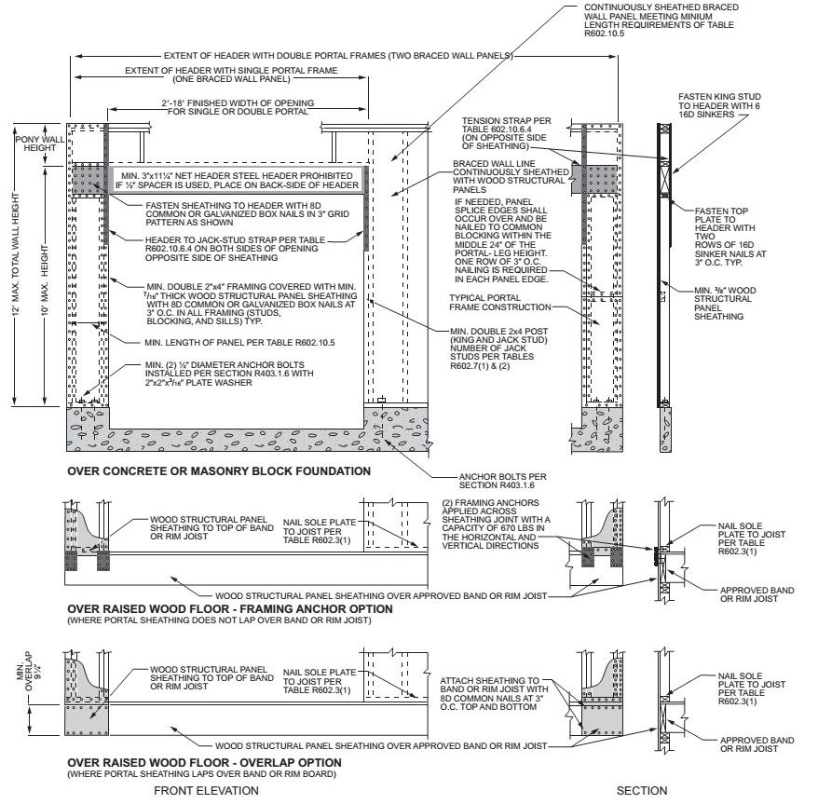
For SI: 1 inch = 25.4 mm, 1 foot = 304.8 mm.
FIGURE R602.10.6.4
METHOD CS-PF—CONTINUOUSLY SHEATHED PORTAL FRAME PANEL CONSTRUCTION

